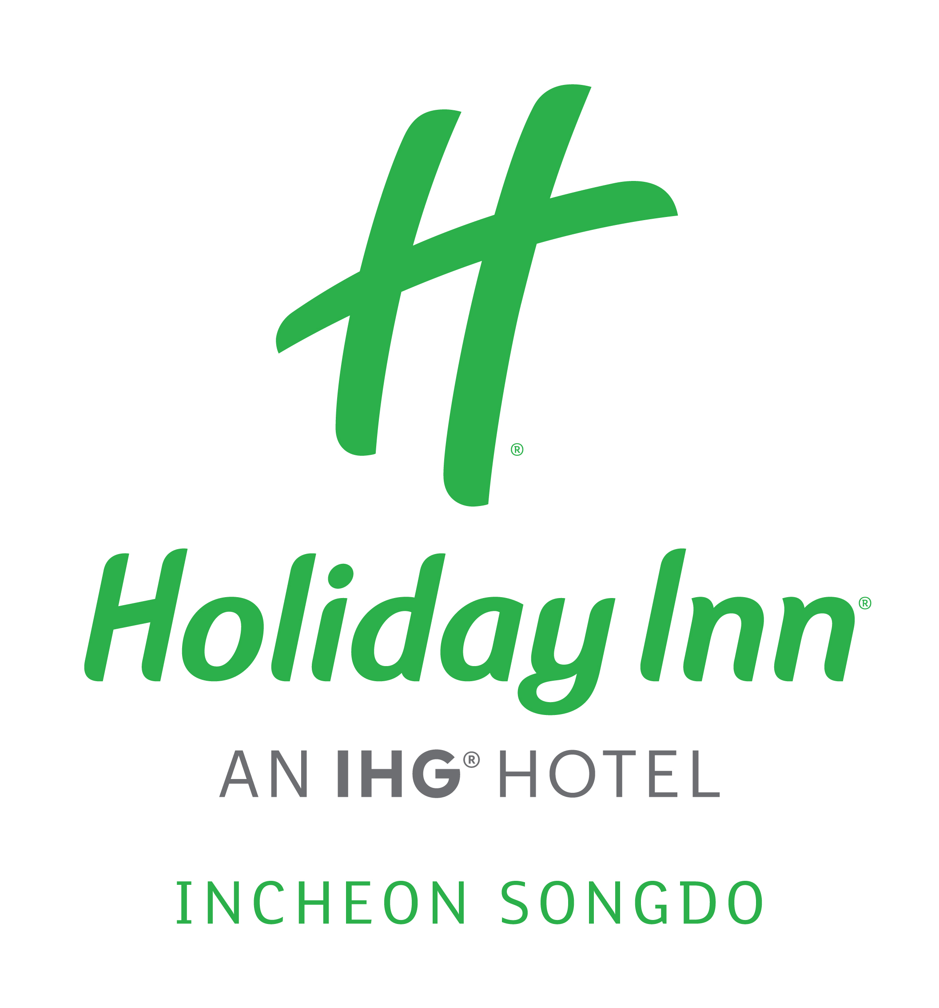
Reservation Form for 2019 The 59th Annual Meeting

* Please complete and return this form to us by email (reservation.songdo@ihg.com) only.

GUEST INFORMATION
Title :

Given Name : | Family Name:
Address : | Country :
States & Postal Code : | E-mail :
Phone :

HOTEL RESERVATION
Arrival Date :
Departure Date :
Room Type & Special Rate ( all rates are including 10% service charge, 10% Tax)
*Superior King (One King size bed) KRW 110,000 (Room Only)
*Superior Twin (Separate two semi-double size bed) KRW 110,000 (Room Only)
Additional Breakfast (rate is including 10% service charge and 10% Tax)
KRW 17,600 (per person) 1 person 2 person
Note: *The room rate is a 2019.10.23~ 10.26 Special contracted rate with the 2019 The 59th Annual Meeting.

RESERVATION GUARANTEE:
Credit Card :
Card Number:
Card Holder : | Expiry Date :
*Bank Transfer | Account No. :
Account Owner : | Swift Code :
Bank Address :

BOOKING CONDITIONS
- Check out time: before 12:00 - Check in time: from 15:00 (There will be extra charges for early check-in and late check-out)
- Non-guaranteed reservations will be held 24 hours prior to arrival, after that the reservations will be automatically released.
- For Guaranteed reservations we would require a credit card with expiration date. In the event of late cancellation within 24 hours prior to arrival or non-arrival, a one night accommodation charge will be applied to the credit card.

